/76

**Physics 30 – Lesson 3B**

**Conservation of Energy**

1)

/3



2)

/3



3)

/4



4)

/4





5)

/3

The roller coaster is frictionless, therefore the total mechanical energy (Ek + Ep) remains constant. In other words the total mechanical energy at B, C and D is equal to the mechanical energy at A.

At B

6)

/9



At C



At D





7)

/4

At B



B

2.0 x 103 kg

14 m/s

25 m

A

C

36 m

8)

/8

At C

There are many ways to approach this problem. I chose the idea that if Ek at C is greater than zero the car will fall off at C.



EkC is negative, therefore the car never reaches point C. The engineer lives!! (Oh well.)

a.

9)

/8



b. The vertical height gained depends only on the vertical component of the velocity as the skier leaves the jump.

45o

28.0 m/s

28.0 sin45

=19.8 m/s





10)

/6

A car with twice the speed will have four times the kinetic energy since Ek depends on the square of the speed (i.e. 22 = 4). Assuming that the friction force is the same in both situations, the distance to stop is given by

11)

/3



With four times the work being done at the same frictional force, the stopping distance will in crease by a factor of 4



12)

/5

First, calculate the amount of energy involved in braking



Using the braking energy we can calculate how fast the car was going



∴the car was going slower than the 100 km/h speed limit



13)

/4

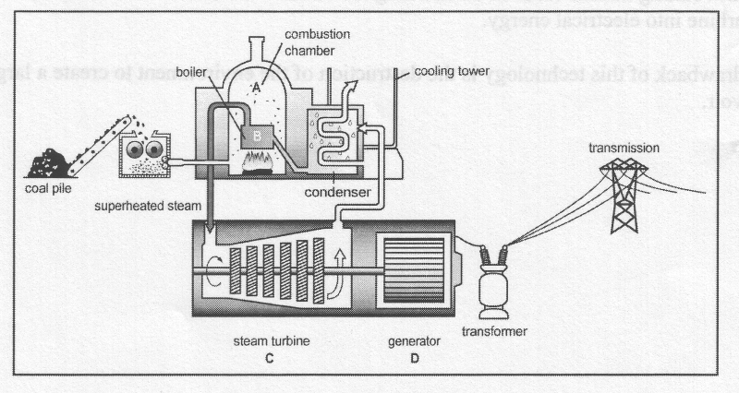The chemical potential energy in the coal is converted into thermal energy via combustion (A). The combustion thermal energy is used to create superheated steam, another form of thermal energy (B). The superheated steam turns a turbine to create mechanical energy (C). The turning turbine is connected to a generator, transforming mechanical into electrical energy (D).

14)

/4

For a nuclear power plant, some of the nuclear binding energy in the uranium atoms is released as thermal energy through fission. 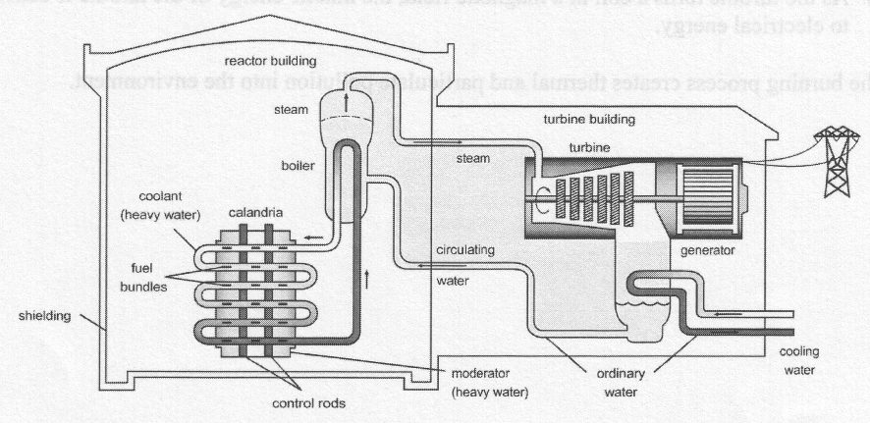 The thermal energy heats the coolant. Via a heat exchanger, the thermal energy of the coolant is used to create superheated steam, another form of thermal energy. The superheated steam turns a turbine to create mechanical energy. The turning turbine is connected to a generator, transforming mechanical into electrical energy.

15)

/4

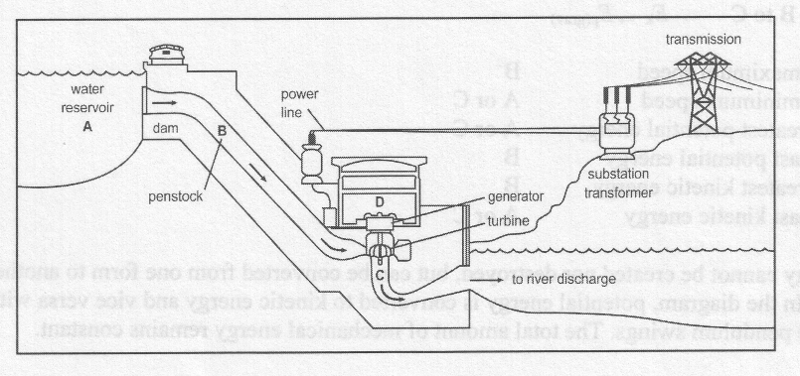For a hydro electric power plant, the gravitational potential energy of the water in the dam (A) is released down the penstock, converting gravitational potential energy into kinetic energy (B). The kinetic energy of the water turns a turbine to create mechanical energy(C). The turning turbine is connected to a generator, transforming mechanical into electrical energy (D).

16)

/4